#### Education for sustainable development & spirituality

PILGRIM combines education for sustainable development with spirituality in the religious-ethical-philosophical dimension of education. It focusses on a sustainable future by encouraging change and strengthening trust in the present. The PILGRIM schools and institutions have been realising this as an educational concept since 2003/4.

#### Spirituality

Even in a secularised and secular world, there are existential questions that affect the concrete shaping of life. The questions of life affect all people at every age: Why am I here? How do I want to live? What is good? A deep view of the world and spirituality emerge from the respective religion that is taught, lived and reflected upon.

Ecology

Economy

Social affairs



Spirituality

Therefore, in addition to the three pillars of sustainability - ecology, economy and social responsibility - we see sustainable development as

- spirituality as the "fourth dimension".

Ecology is thus experienced as wonder at the world, as reflection on the place and task of mankind.

Economy then appears as a gift and a task, labour as a form of service to God and mankind.

Social issues become a mission to see all people in their dignity and likeness to God.

Spirituality can therefore enrich and bring together the various educational contents, embrace the whole person and promote commitment to sustainable development. Those who know the why can change their behaviour. Seeing the world with „sacra mente… ...

#### Strengthening religious education

* PILGRIM project

Usually based on religious education lessons and work in a cooperative and interdisciplinary manner. The activities take place in the school building, in nature, in a retirement home or a company/institution. The holistic nature of the activities strengthens pupils and teachers. Acquisition of competences and skills.

* The certification event

The certification event takes place every year. There, each school/institution receives the document, a PILGRIM ceramic plaque and a vine.

* Participation in the PILGRIM network for at least 5 years

To ensure that the projects do not remain isolated initiatives, the topics must be implemented consistently.

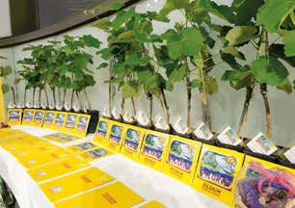



Image © Rupprecht/kathbild.at

Pictures: BG-Purkersdorf, VS Oberloisdorf

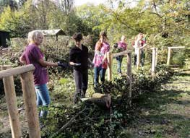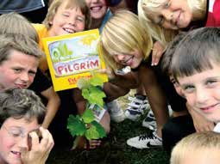

#### Creating the experts

In the years 2021 to 2023, the programme for the upper school was developed in cooperation between the Centre for Education for Sustainable Development & Spirituality at KPH Vienna/Krems and two PILG- RIM schools in Vienna and Lower Austria. It was trialled in a pilot programme at the Vienna Business School Akademiestraße last school year. The ceremonial appointment of the new 40 Mit-Welt-Expert*innen in the sixth form was organised in the presence of PILGRIM founder Dr Johann Hisch. The pass for the upper school can be ordered from PILGRIM and the Centre of the KPH Vienna/Krems.

Pupils select five topics and five suggestions from each and enter them in this Mit-Welt-Experten booklet. The total of 25 individual tasks give them the feeling that they have done something for creation. This feeling of satisfaction can be transferred to other topics and leads to new ways of thinking and acting. The community of the class, school and family plays a major role here. In the sense: every action has two sides - on the one hand to save the world - on the other hand to serve creation ...

#### Appointment of experts

After the pupils have completed the 5 topics, each with 5 tasks from the Mit-Welt-Experten-booklet, they are appointed experts. This takes place during a ceremony at their own school. The KPH Vienna/Krems team, together with the PILGRIM board and the responsible local teachers, prepare certificates for the new experts and present them at a ceremony in the school. With the certificates, the pupils receive confirmation of their competences, which they can now use in their school and in their environment. PILGRIM experts have already been appointed at a number of primary and lower secondary schools and an integration school in Vienna, as well as at the Vienna Business School Akademiestraße. Others, such as in Jelgava/Lettlant, are planned.

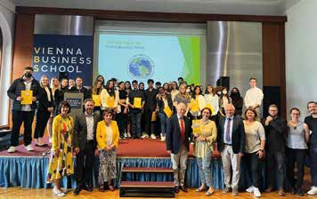



MIT-WELT- EXPERT: IN

#### PILGRIM-Statistics

Status: end of 2023

